**SOFTWARE**

**DESIGN  
DOCUMENT**

**For Second-Hands Goods Sales System**

**Kais Abiyyi 2350081061**

**Nazar Muhammad Fikri Fadhillah 2350081063**

**Jarwo Eddy Wicaksono 2350081064**

# **1. Introduction**

## **1.1 Purpose**

This Software Design Document (SDD) defines the high-level and detailed design of the **Second-Hands Goods Sales System** based on the approved SRS. It is intended to guide developers, testers, and maintainers during implementation and future evolution of the system.

## **1.2 Scope**

The system is a web-based application that enables:

* Customers to browse second-hand goods, place orders, make payments (QRIS and cash), and track deliveries.
* Administrators to manage categories, items, users, orders, payments, shipments, and reports.

## **1.3 Definitions, Acronyms, and Abbreviations**

* **SDD** – Software Design Document
* **SRS** – Software Requirements Specification
* **API** – Application Programming Interface
* **DB** – Database
* **QRIS** – QR-based payment standard used in Indonesia

## **1.4 References**

* Second-Hands Goods Sales System – SRS (latest version)

# **2. System Overview**

## **2.1 System Description**

The system is a typical three-tier web application:

* **Presentation Layer** – Web UI accessed by customers and admins.
* **Application Layer** – Backend application exposing APIs and business logic.
* **Data Layer** – Relational database storing users, items, orders, payments, and shipments.

Two main roles interact with the system:

* **Customer**: searches items, places orders, pays, and tracks shipments.
* **Admin** (and optionally Owner): manages operational data and views reports.

## **2.2 System Context (Textual)**

* External actor **Customer** interacts via browser with the web application.
* External actor **Admin** interacts via browser with the admin interface.
* The web application communicates with a **Database Server** for persistent data.
* For QRIS payments, the backend interacts with an external **QRIS Payment Gateway**.

# **3. Application Design**

This chapter describes the application behavior and structure using standard UML diagrams. Each subsection lists the diagrams that should be produced for this system. For every diagram, only the name (as a sub-subsection title) and a very short description are provided.

## **3.1 Use Case Diagram**

Use case diagrams capture functional interactions between actors and the system.

### **3.1.1 Overall System**

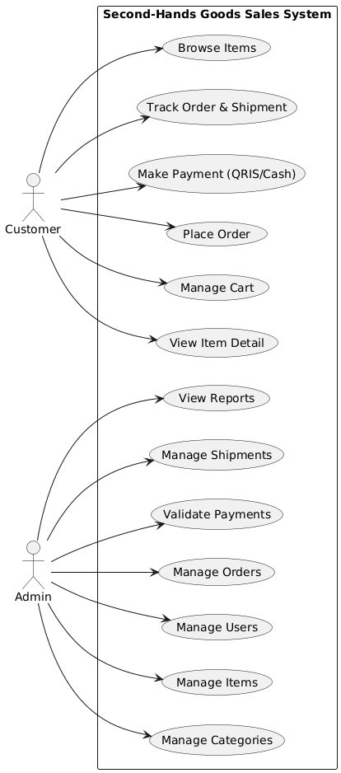

### **3.1.2 Customer Role**

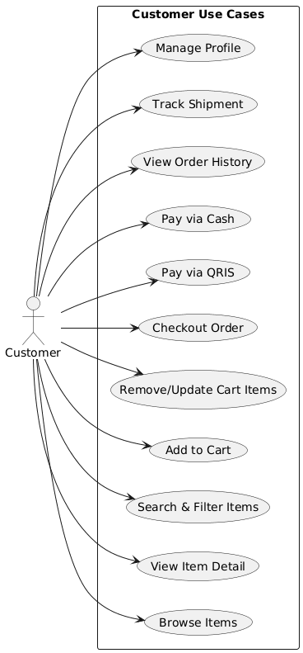

### **3.1.3 Admin Role**

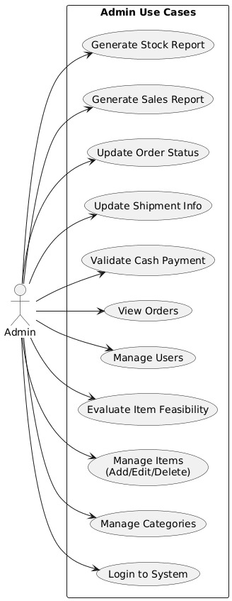

## **3.2 Use Case Scenario**

Use case scenarios describe step-by-step flows (text-based) for key use cases.

### **3.2.1 Customer Browse and View Item Detail**

Scenario describing how a customer searches, filters, and views item details in the catalog.

### **3.2.2 Customer Place Order with QRIS Payment**

Scenario describing how a customer adds items to cart, checks out, and completes payment using QRIS.

### **3.2.3 Customer Place Order with Cash Payment**

Scenario describing how a customer places an order and chooses cash payment at the store.

### **3.2.4 Customer Track Order and Shipment**

Scenario describing how a customer views order history and tracks shipment status.

### **3.2.5 Admin Manage Categories and Items**

Scenario describing how an admin creates, updates, and removes categories and items, including feasibility status.

### **3.2.6 Admin Validate Cash Payment**

Scenario describing how an admin confirms cash payments and updates payment status.

### **3.2.7 Admin Manage Shipments**

Scenario describing how an admin enters courier information, tracking numbers, and updates shipment status.

### **3.2.8 Admin View Sales and Stock Reports**

Scenario describing how an admin generates and views sales and inventory reports.

## **3.3 Class Diagram**

Class diagrams describe the static structure of the system in terms of classes, attributes, operations, and relationships.

### **3.3.1 Domain Model**

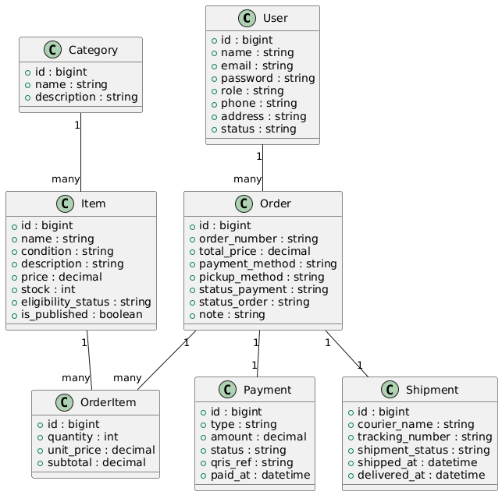

### **3.3.2 Application / Service Layer**

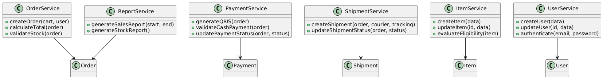

### **3.3.3 Controller and View Layer**



## **3.4 Sequence Diagram**

Sequence diagrams show the dynamic interaction between objects over time for major flows.

### **3.4.1 Customer Checkout with QRIS Payment**

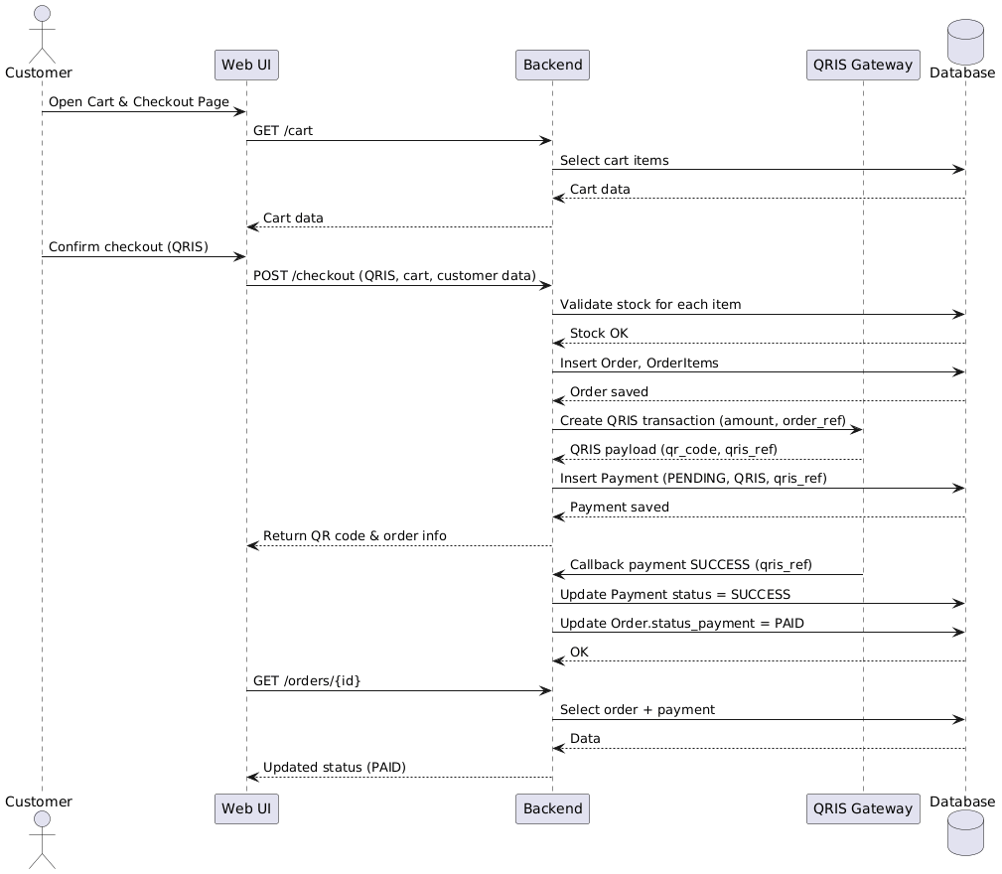

### **3.4.2 Customer Checkout with Cash Payment**

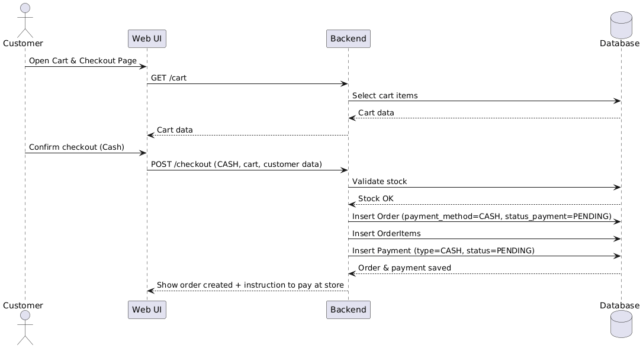

### **3.4.3 Customer Views Order History and Detail**

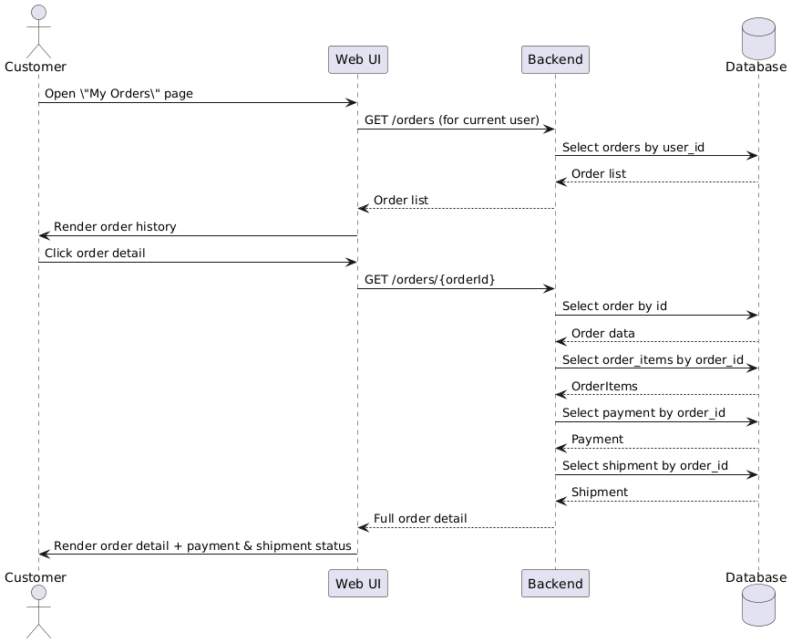

### **3.4.4 Admin Confirms Cash Payment**

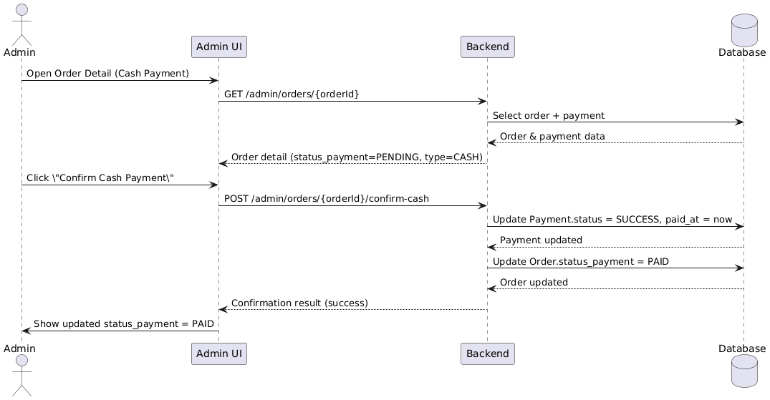

### **3.4.5 Admin Updates Shipment Information**

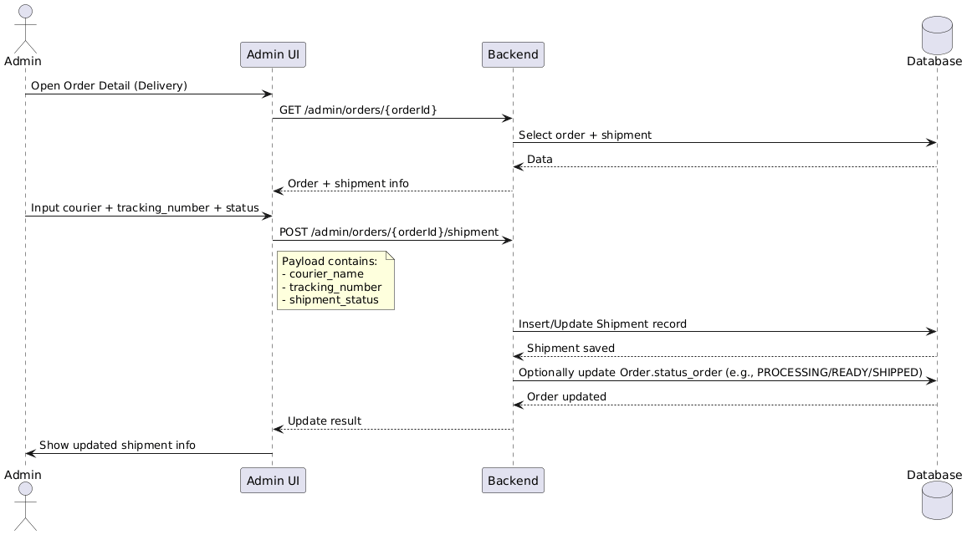

### **3.4.6 Admin Generates Sales Report**

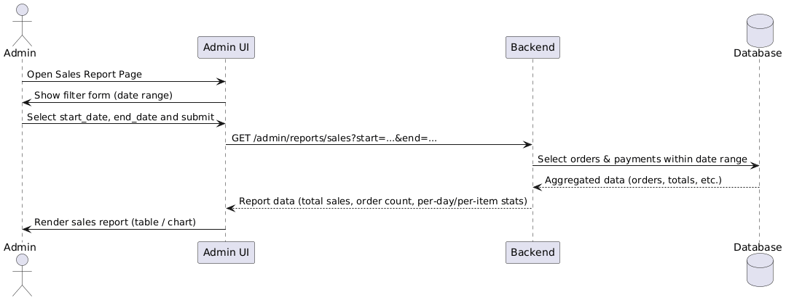

## **3.5 Activity Diagram**

Activity diagrams model workflows for key business processes.

### **3.5.1 Customer Purchase Flow**

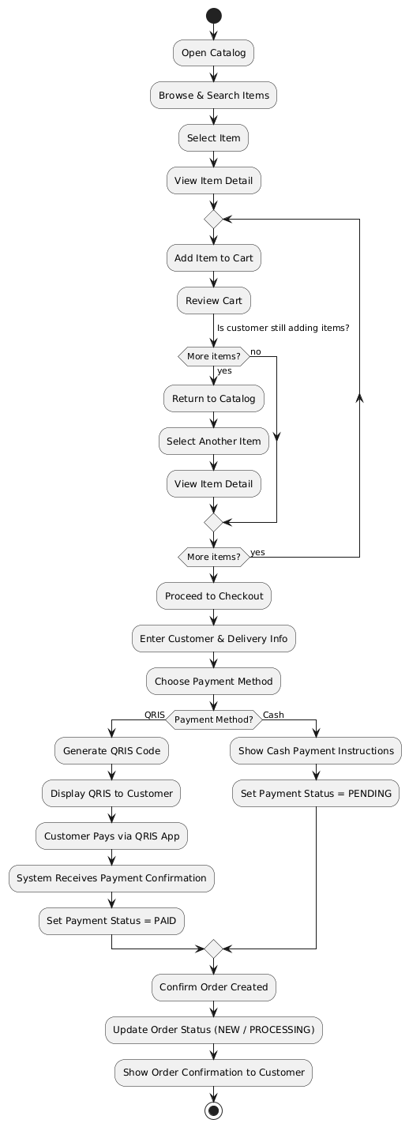

### **3.5.2 Admin Order Fulfillment Flow**

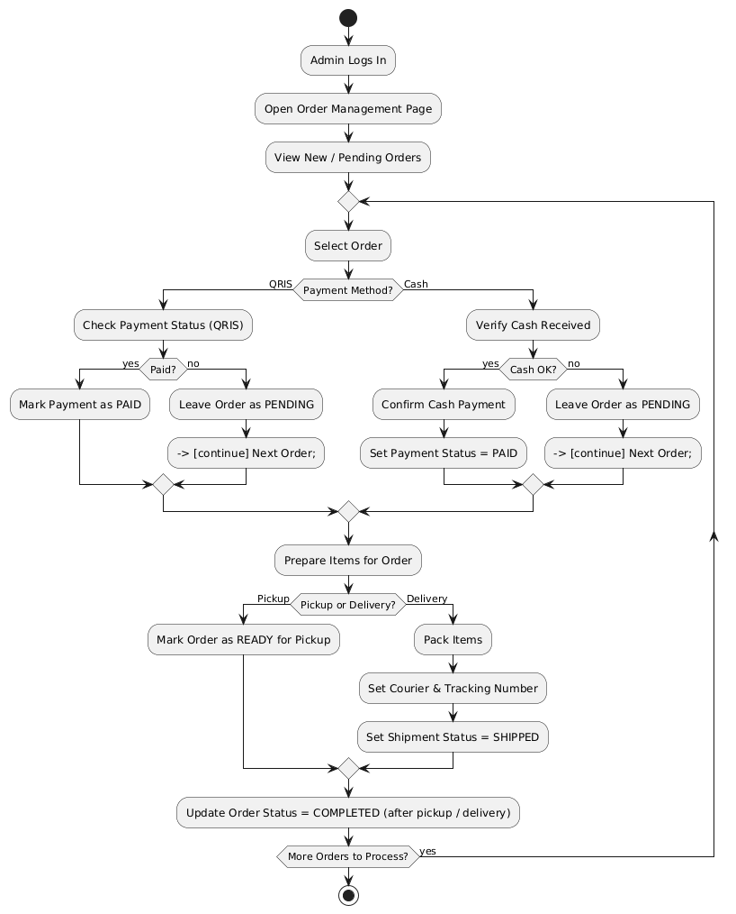

### **3.5.3 Inventory Management Flow**

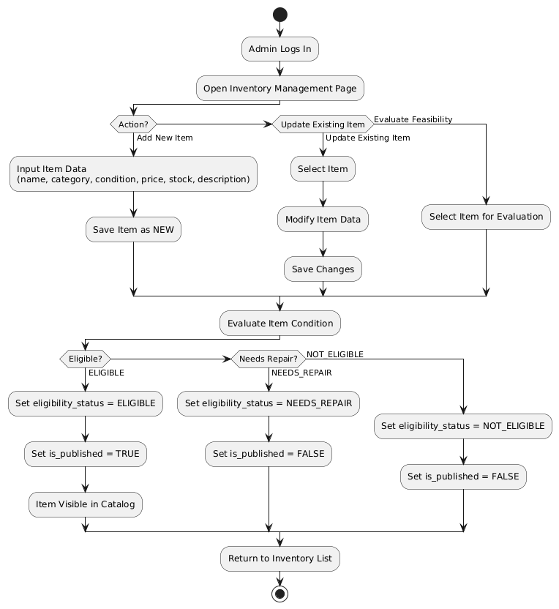

### **3.5.4 Payment Handling Flow**

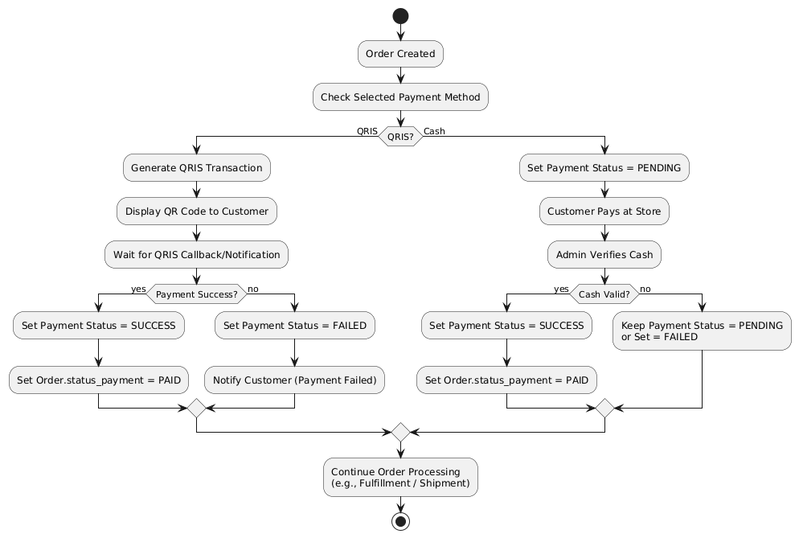

## **3.6 State Diagram**

State diagrams describe lifecycle states and transitions of important entities.

### **3.6.1 Order Lifecycle**

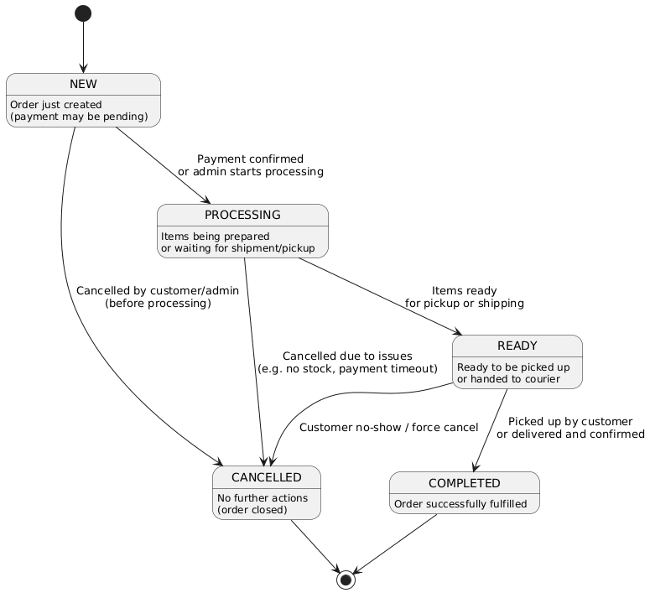

### **3.6.2 Payment Lifecycle**

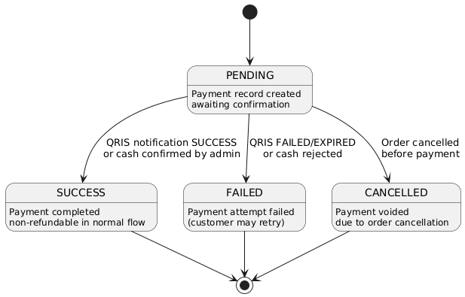

### **3.6.3 Shipment Lifecycle**

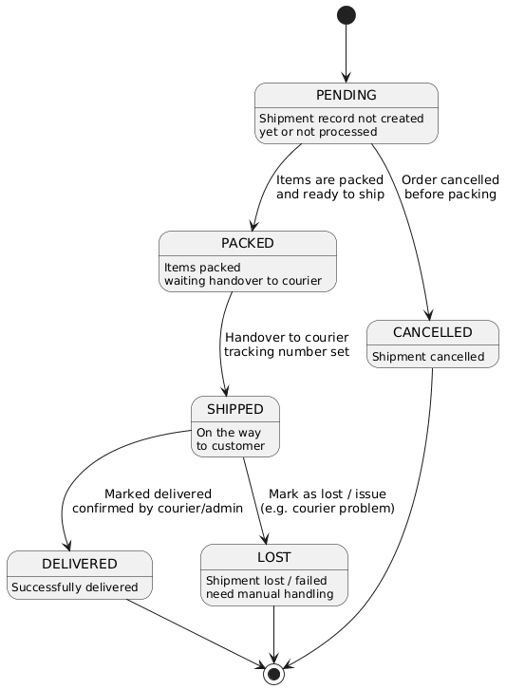

### **3.6.4 Item Eligibility Status**

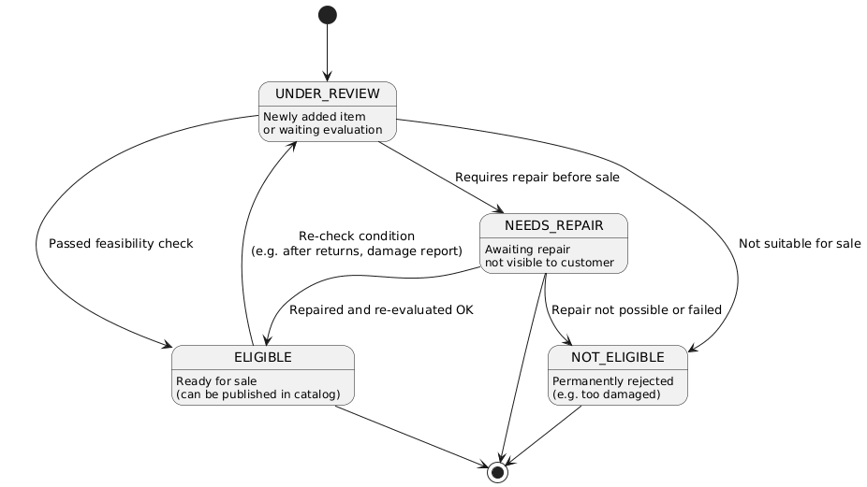

## **3.7 Deployment Diagram**

Deployment diagrams show how software components are deployed on hardware nodes.

### **3.7.1 Production Environment**

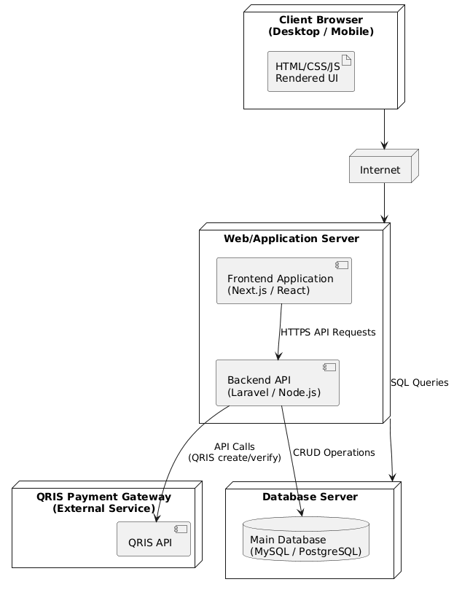

### **3.7.2 Development / Test Environment**

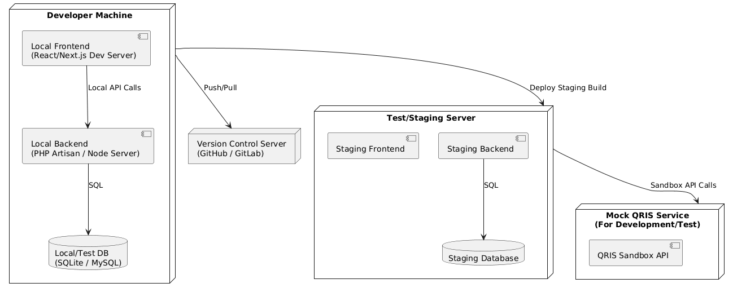

# **4. Data Design**

## **4.1 Logical Design**

The logical data design is represented by an **Entity Relationship Diagram (ERD)** describing main entities and their relationships.

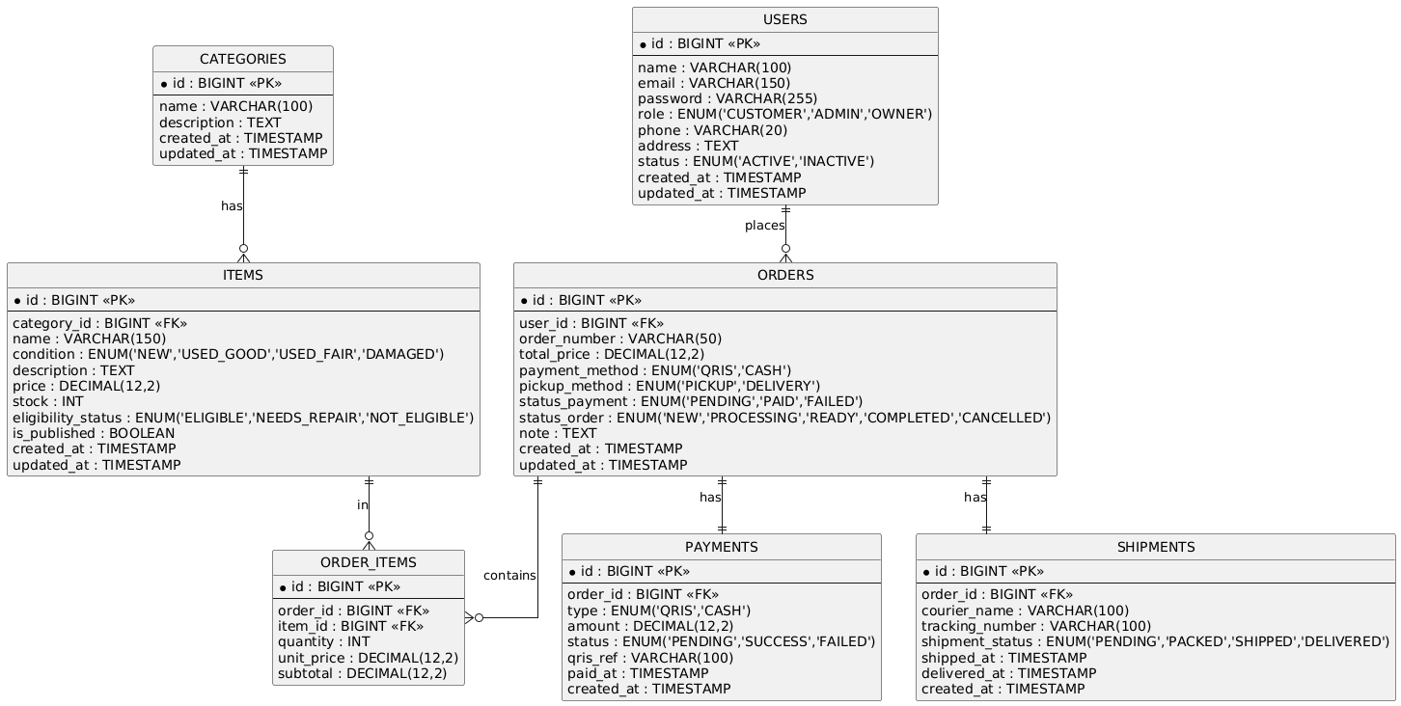

Main logical entities:

* Users
* Categories
* Items
* Orders
* OrderItems
* Payments
* Shipments

Main logical relationships:

* One User places many Orders.
* One Category contains many Items.
* One Order contains many OrderItems.
* One Item can appear in many OrderItems.
* One Order has one Payment (or multiple, if retry is supported).
* One Order has one Shipment record for delivery.

## **4.2 Physical Design**

The physical design defines the actual table structures and relationships in the relational database.

### **4.2.1 Users Table**

| **Column** | **Type** | **Constraints** | **Description** |
| --- | --- | --- | --- |
| id | BIGINT | PK, AUTO INCREMENT | Unique user identifier |
| name | VARCHAR(100) | NOT NULL | Full name |
| email | VARCHAR(150) | NOT NULL, UNIQUE | Login identifier |
| password | VARCHAR(255) | NOT NULL | Hashed password |
| role | ENUM('CUSTOMER','ADMIN','OWNER') | NOT NULL | Role used for authorization |
| phone | VARCHAR(20) | NULL | Phone number |
| address | TEXT | NULL | Default shipping/billing address |
| status | ENUM('ACTIVE','INACTIVE') | DEFAULT 'ACTIVE' | Account status |
| created_at | TIMESTAMP | DEFAULT CURRENT_TIMESTAMP | Record creation time |
| updated_at | TIMESTAMP | DEFAULT CURRENT_TIMESTAMP ON UPDATE | Last update time |

### **4.2.2 Categories Table**

| **Column** | **Type** | **Constraints** | **Description** |
| --- | --- | --- | --- |
| id | BIGINT | PK, AUTO INCREMENT | Unique category identifier |
| name | VARCHAR(100) | NOT NULL, UNIQUE | Category name |
| description | TEXT | NULL | Category description |
| created_at | TIMESTAMP | DEFAULT CURRENT_TIMESTAMP | Creation time |
| updated_at | TIMESTAMP | DEFAULT CURRENT_TIMESTAMP ON UPDATE | Last update time |

### **4.2.3 Items Table**

| **Column** | **Type** | **Constraints** | **Description** |
| --- | --- | --- | --- |
| id | BIGINT | PK, AUTO INCREMENT | Unique item identifier |
| category_id | BIGINT | FK → categories.id, NOT NULL | Category of the item |
| name | VARCHAR(150) | NOT NULL | Item name |
| condition | ENUM('NEW','USED_GOOD','USED_FAIR','DAMAGED') | NOT NULL | Item physical condition |
| description | TEXT | NULL | Detailed description |
| price | DECIMAL(12,2) | NOT NULL | Selling price |
| stock | INT | NOT NULL, DEFAULT 0 | Available stock |
| eligibility_status | ENUM('ELIGIBLE','NEEDS_REPAIR','NOT_ELIGIBLE') | NOT NULL | Feasibility status |
| is_published | BOOLEAN | DEFAULT TRUE | Whether item is visible in catalog |
| created_at | TIMESTAMP | DEFAULT CURRENT_TIMESTAMP | Creation time |
| updated_at | TIMESTAMP | DEFAULT CURRENT_TIMESTAMP ON UPDATE | Last update time |

### **4.2.4 Orders Table**

| **Column** | **Type** | **Constraints** | **Description** |
| --- | --- | --- | --- |
| id | BIGINT | PK, AUTO INCREMENT | Unique order identifier |
| user_id | BIGINT | FK → users.id, NOT NULL | Customer placing the order |
| order_number | VARCHAR(50) | UNIQUE, NOT NULL | Human-readable order code |
| total_price | DECIMAL(12,2) | NOT NULL | Total order amount |
| payment_method | ENUM('QRIS','CASH') | NOT NULL | Selected payment method |
| pickup_method | ENUM('PICKUP','DELIVERY') | NOT NULL | How customer receives goods |
| status_payment | ENUM('PENDING','PAID','FAILED') | DEFAULT 'PENDING' | Payment status |
| status_order | ENUM('NEW','PROCESSING','READY','COMPLETED','CANCELLED') | DEFAULT 'NEW' | Order processing status |
| note | TEXT | NULL | Optional admin/customer notes |
| created_at | TIMESTAMP | DEFAULT CURRENT_TIMESTAMP | Order time |
| updated_at | TIMESTAMP | DEFAULT CURRENT_TIMESTAMP ON UPDATE | Last update time |

### **4.2.5 OrderItems Table**

| **Column** | **Type** | **Constraints** | **Description** |
| --- | --- | --- | --- |
| id | BIGINT | PK, AUTO INCREMENT | Unique order item identifier |
| order_id | BIGINT | FK → orders.id, NOT NULL | Parent order |
| item_id | BIGINT | FK → items.id, NOT NULL | Purchased item |
| quantity | INT | NOT NULL, CHECK(quantity > 0) | Quantity ordered |
| unit_price | DECIMAL(12,2) | NOT NULL | Price per unit at time of order |
| subtotal | DECIMAL(12,2) | NOT NULL | quantity * unit_price |

### **4.2.6 Payments Table**

| **Column** | **Type** | **Constraints** | **Description** |
| --- | --- | --- | --- |
| id | BIGINT | PK, AUTO INCREMENT | Unique payment identifier |
| order_id | BIGINT | FK → orders.id, NOT NULL | Related order |
| type | ENUM('QRIS','CASH') | NOT NULL | Payment type |
| amount | DECIMAL(12,2) | NOT NULL | Paid amount |
| status | ENUM('PENDING','SUCCESS','FAILED') | DEFAULT 'PENDING' | Payment status |
| qris_ref | VARCHAR(100) | NULL | QRIS transaction reference |
| paid_at | TIMESTAMP | NULL | Payment completion timestamp |
| created_at | TIMESTAMP | DEFAULT CURRENT_TIMESTAMP | Record creation |

### **4.2.7 Shipments Table**

| **Column** | **Type** | **Constraints** | **Description** |
| --- | --- | --- | --- |
| id | BIGINT | PK, AUTO INCREMENT | Unique shipment identifier |
| order_id | BIGINT | FK → orders.id, NOT NULL | Related order |
| courier_name | VARCHAR(100) | NULL | Courier service name |
| tracking_number | VARCHAR(100) | NULL, UNIQUE | Shipment tracking number |
| shipment_status | ENUM('PENDING','PACKED','SHIPPED','DELIVERED') | DEFAULT 'PENDING' | Shipment status |
| shipped_at | TIMESTAMP | NULL | Time shipped |
| delivered_at | TIMESTAMP | NULL | Time delivered |
| created_at | TIMESTAMP | DEFAULT CURRENT_TIMESTAMP | Creation time |

### **4.2.8 Relationships Summary**

| **Parent Table** | **Child Table** | **Relationship Type** | **Foreign Key** |
| --- | --- | --- | --- |
| users | orders | 1 : N | orders.user_id → users.id |
| categories | items | 1 : N | items.category_id → categories.id |
| orders | order_items | 1 : N | order_items.order_id → orders.id |
| items | order_items | 1 : N | order_items.item_id → items.id |
| orders | payments | 1 : 1 (or 1 : N*) | payments.order_id → orders.id |
| orders | shipments | 1 : 1 | shipments.order_id → orders.id |

*Note: Payments can be modeled as 1:N if the system needs to support multiple payment attempts per order.*6.4 Communication Interface Requirements

# **5. User Interface Design**

This chapter provides a high-level view of the main user interface components without detailed mockups.

## **Customer Interface**

* Home / Catalog Page

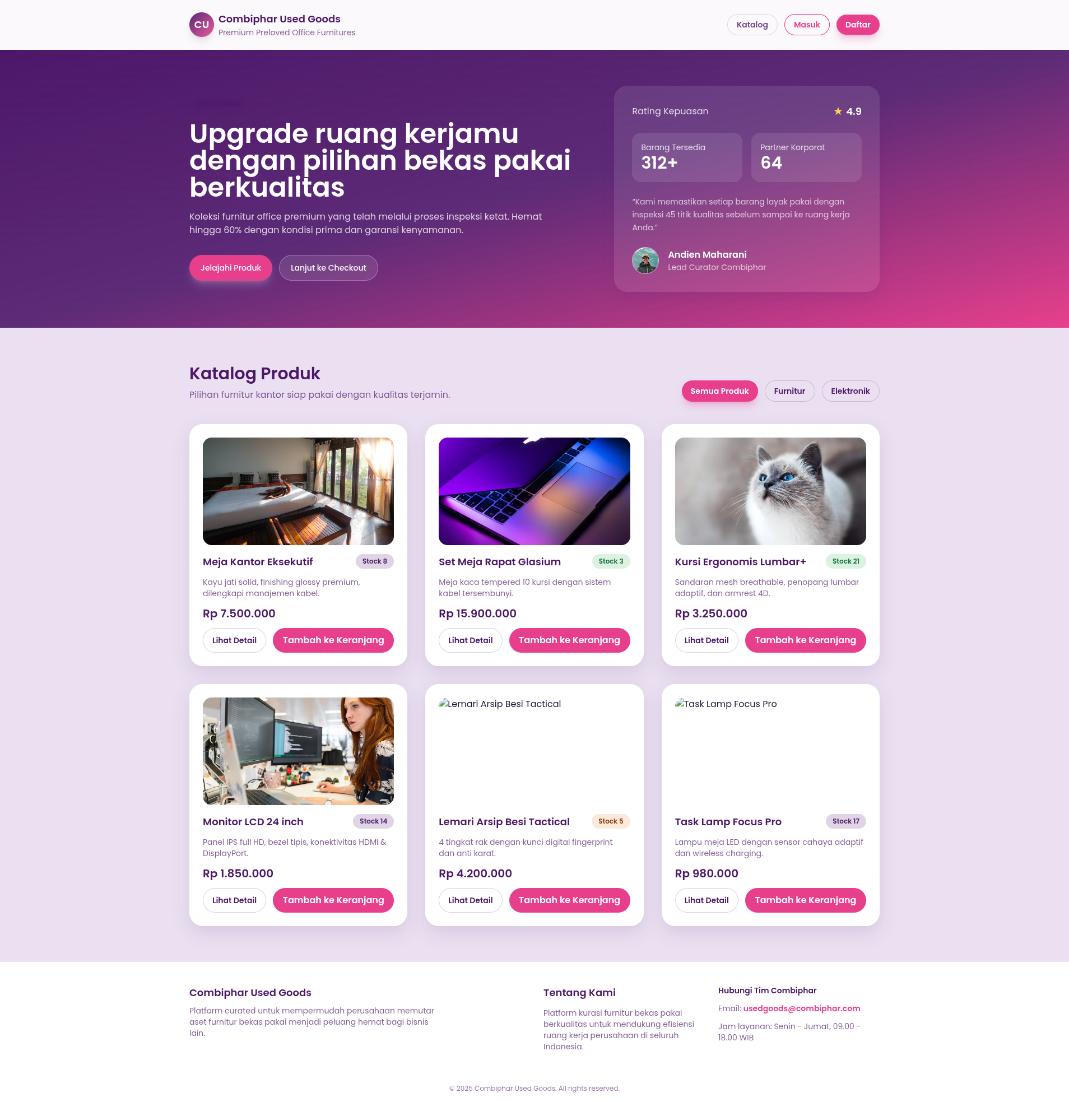

* Product Detail Page

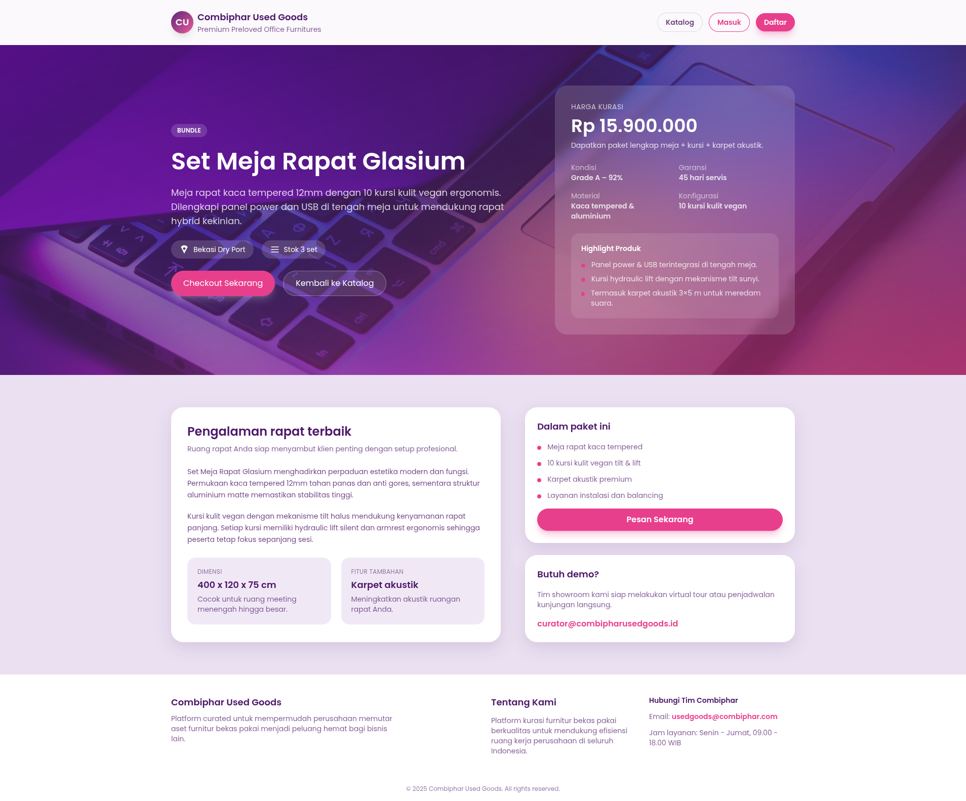

* Cart Page

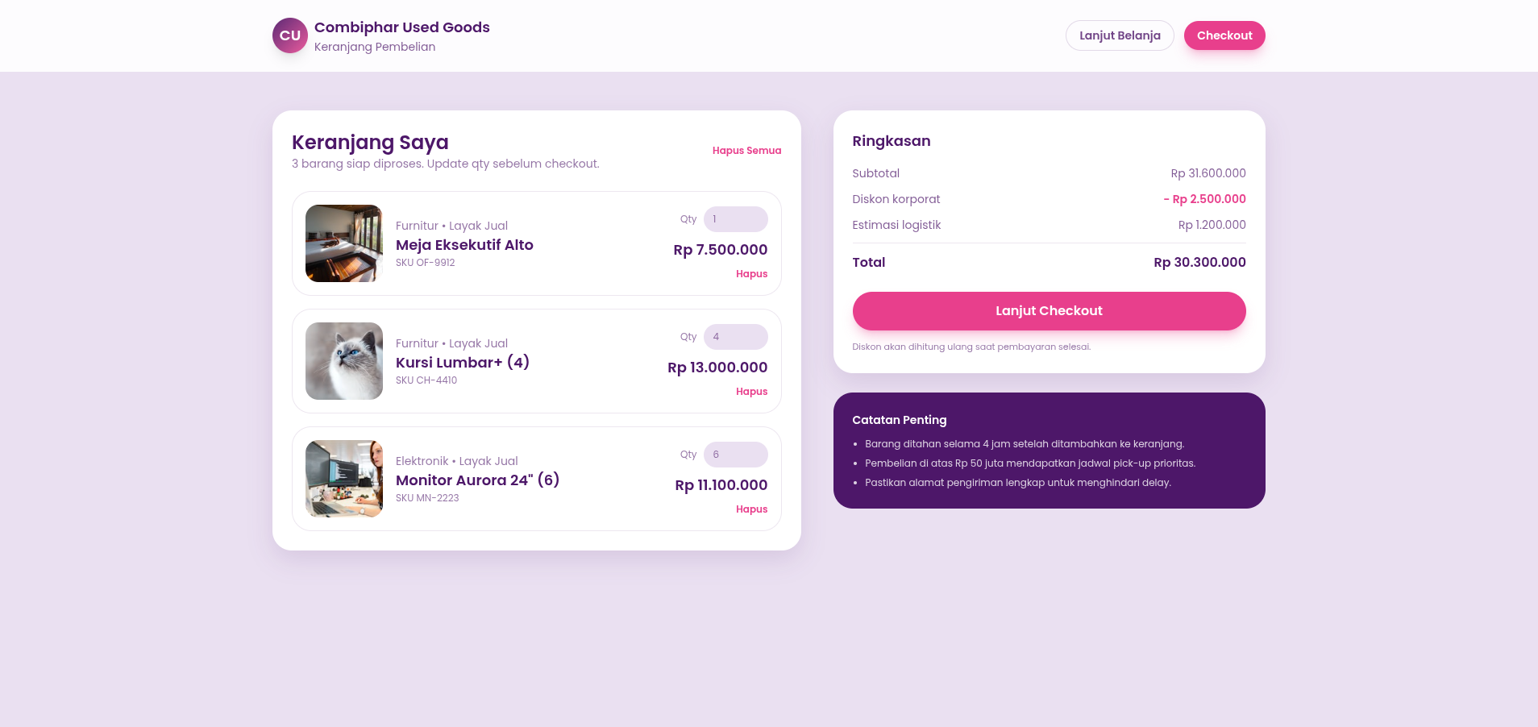

* Checkout Page

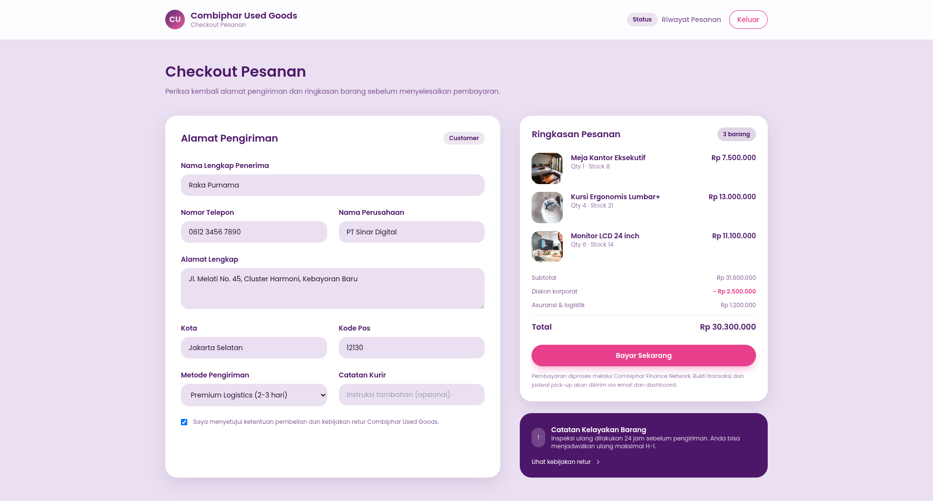

* Payment Page (QRIS)

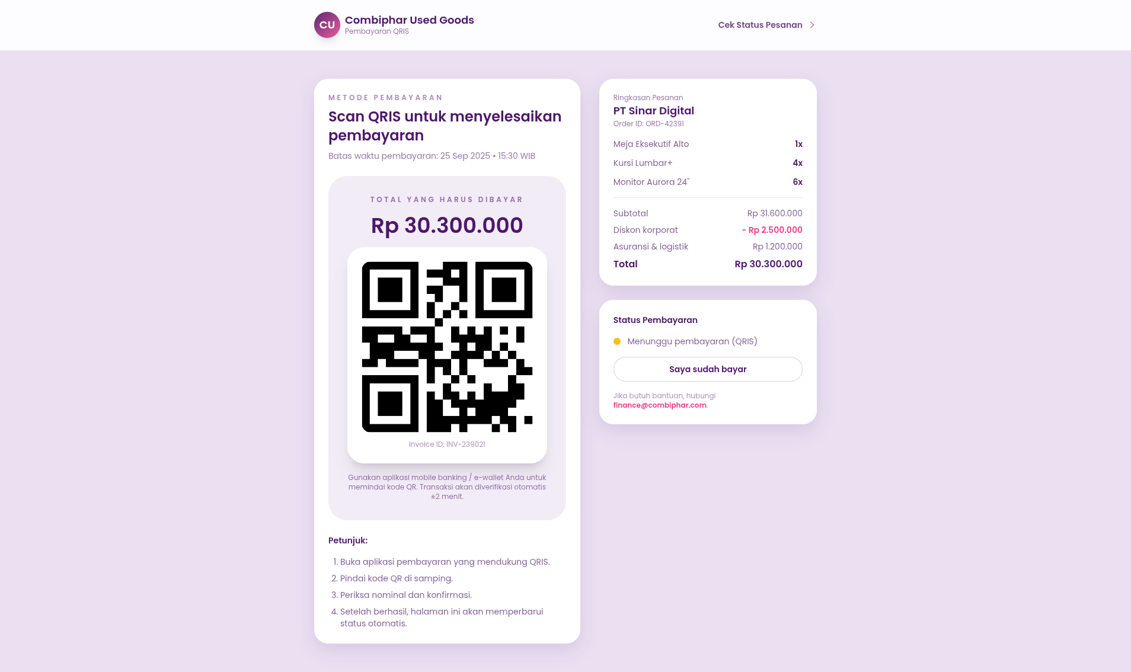

* Order History Page

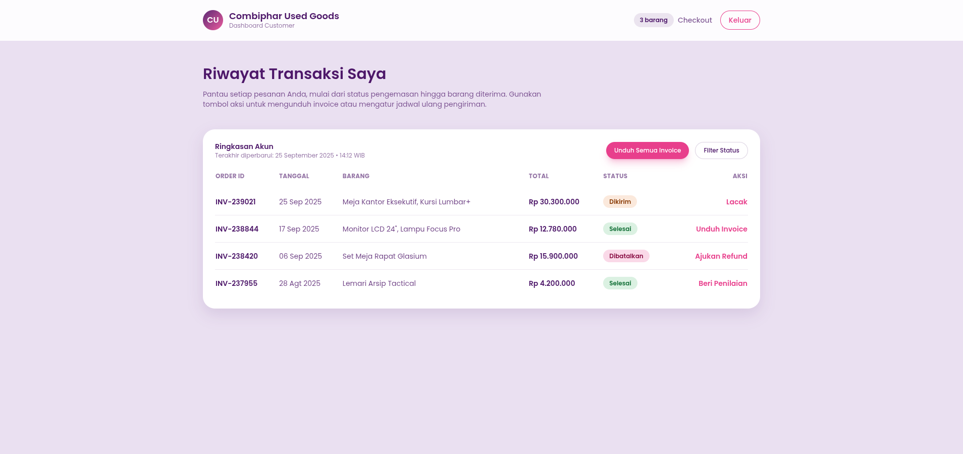

* Order Detail / Tracking Page

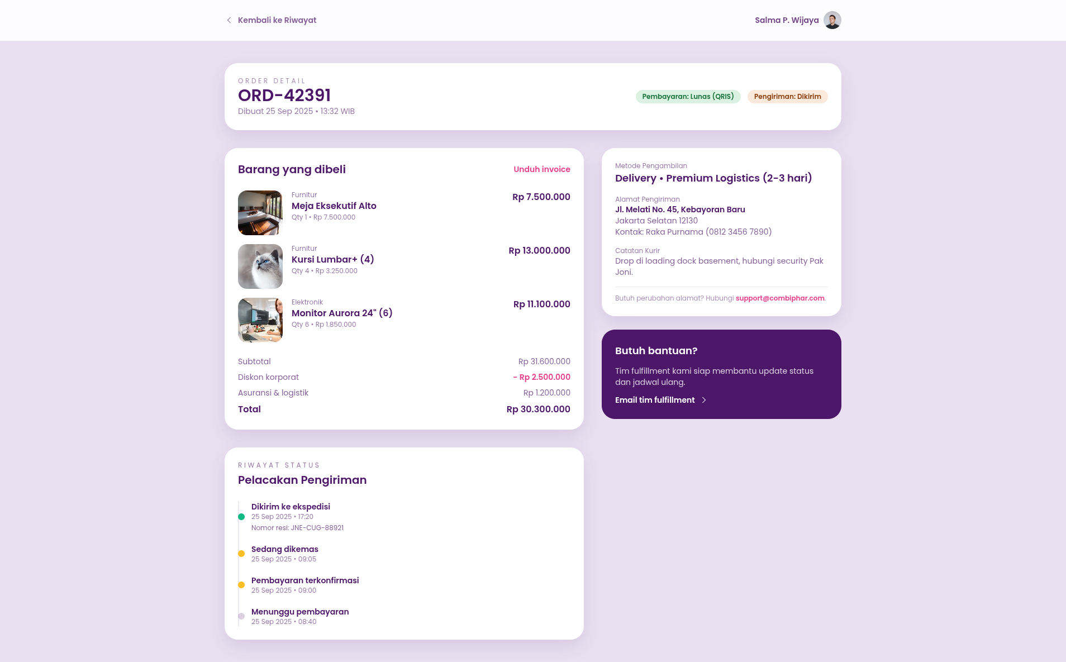

* Profile Page

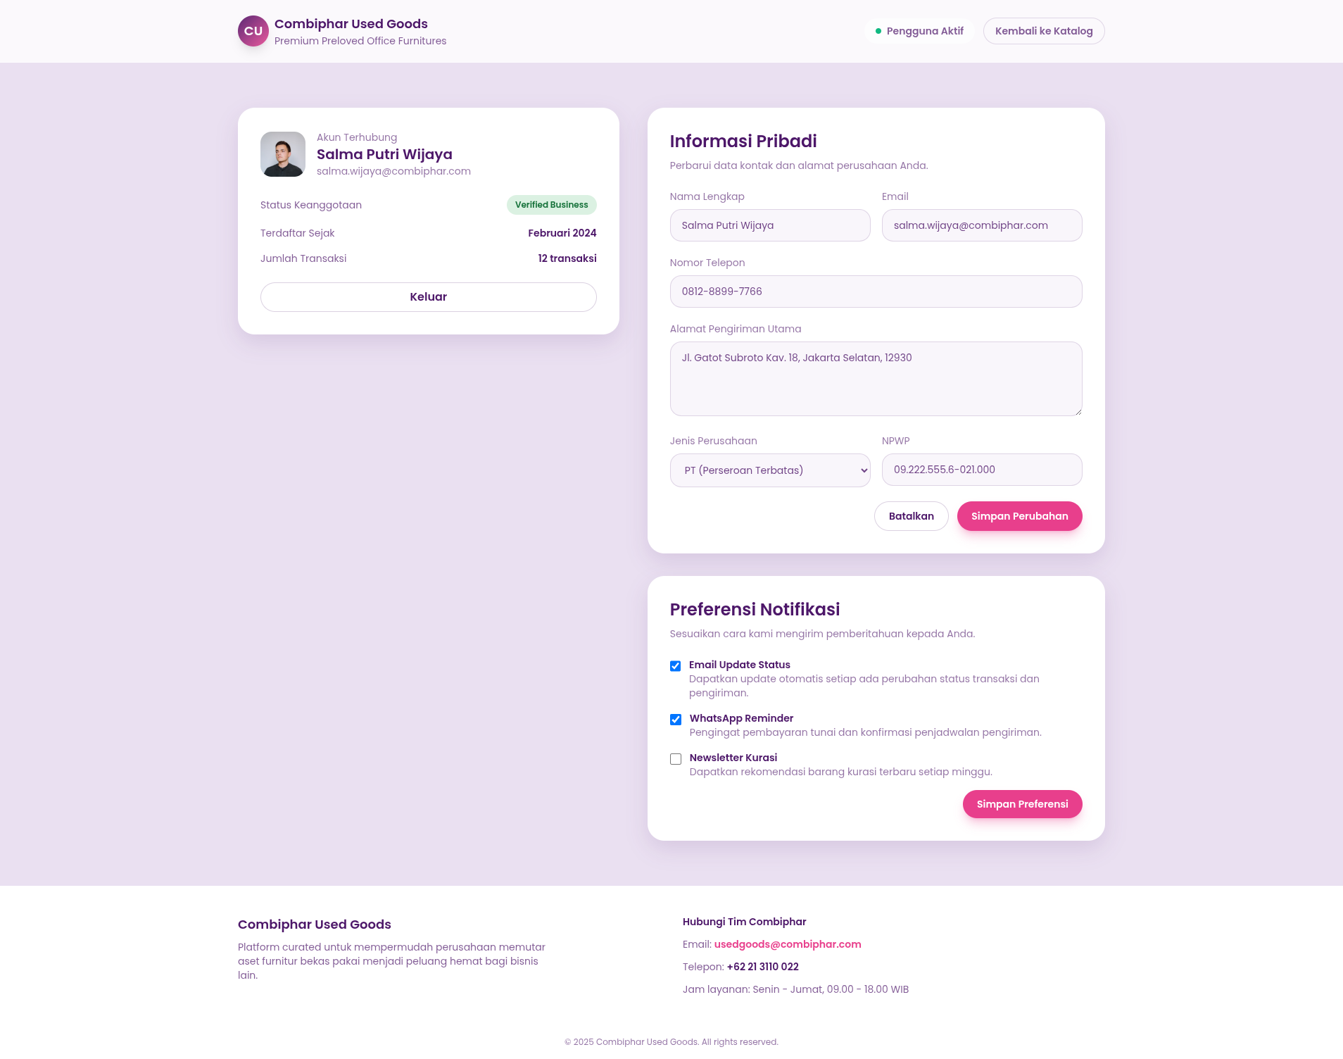

## **Admin Interface**

* Admin Login Page

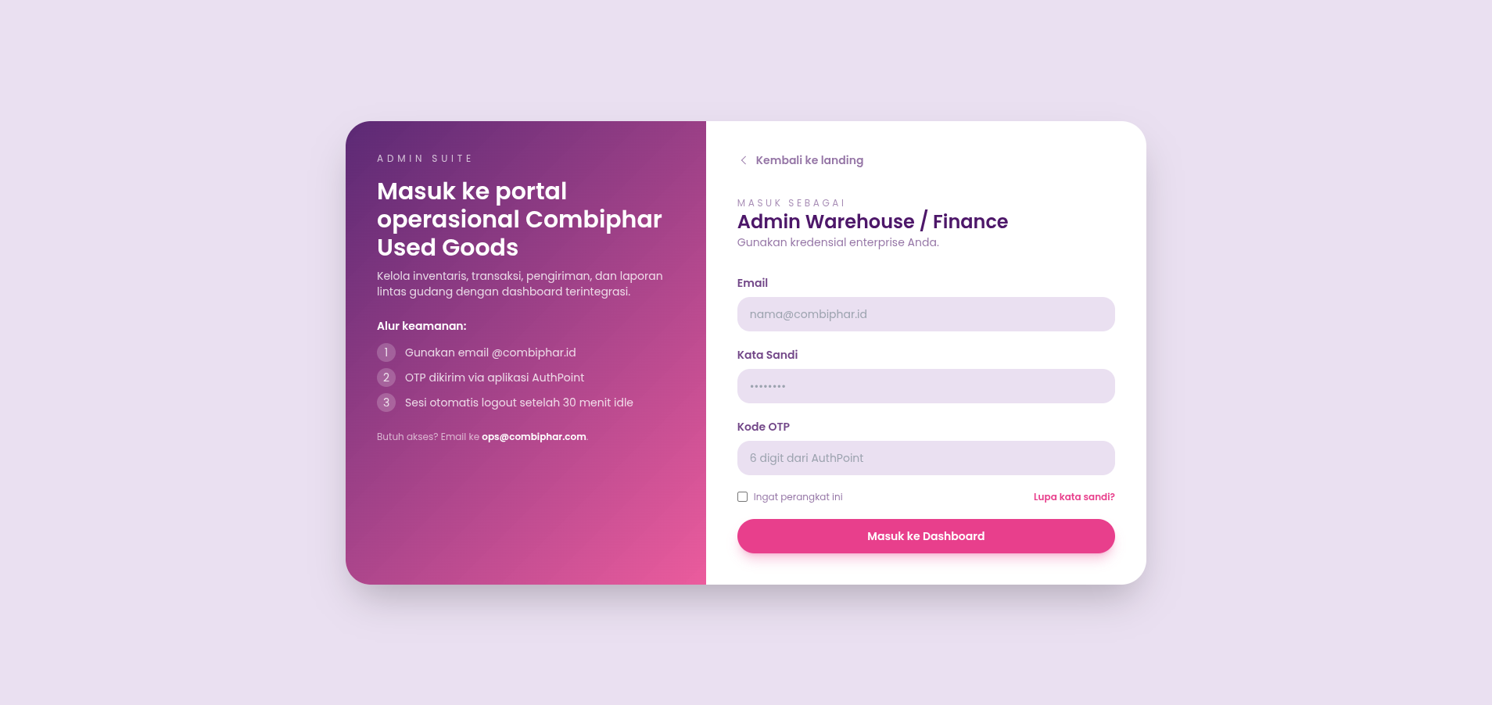

* Admin Dashboard

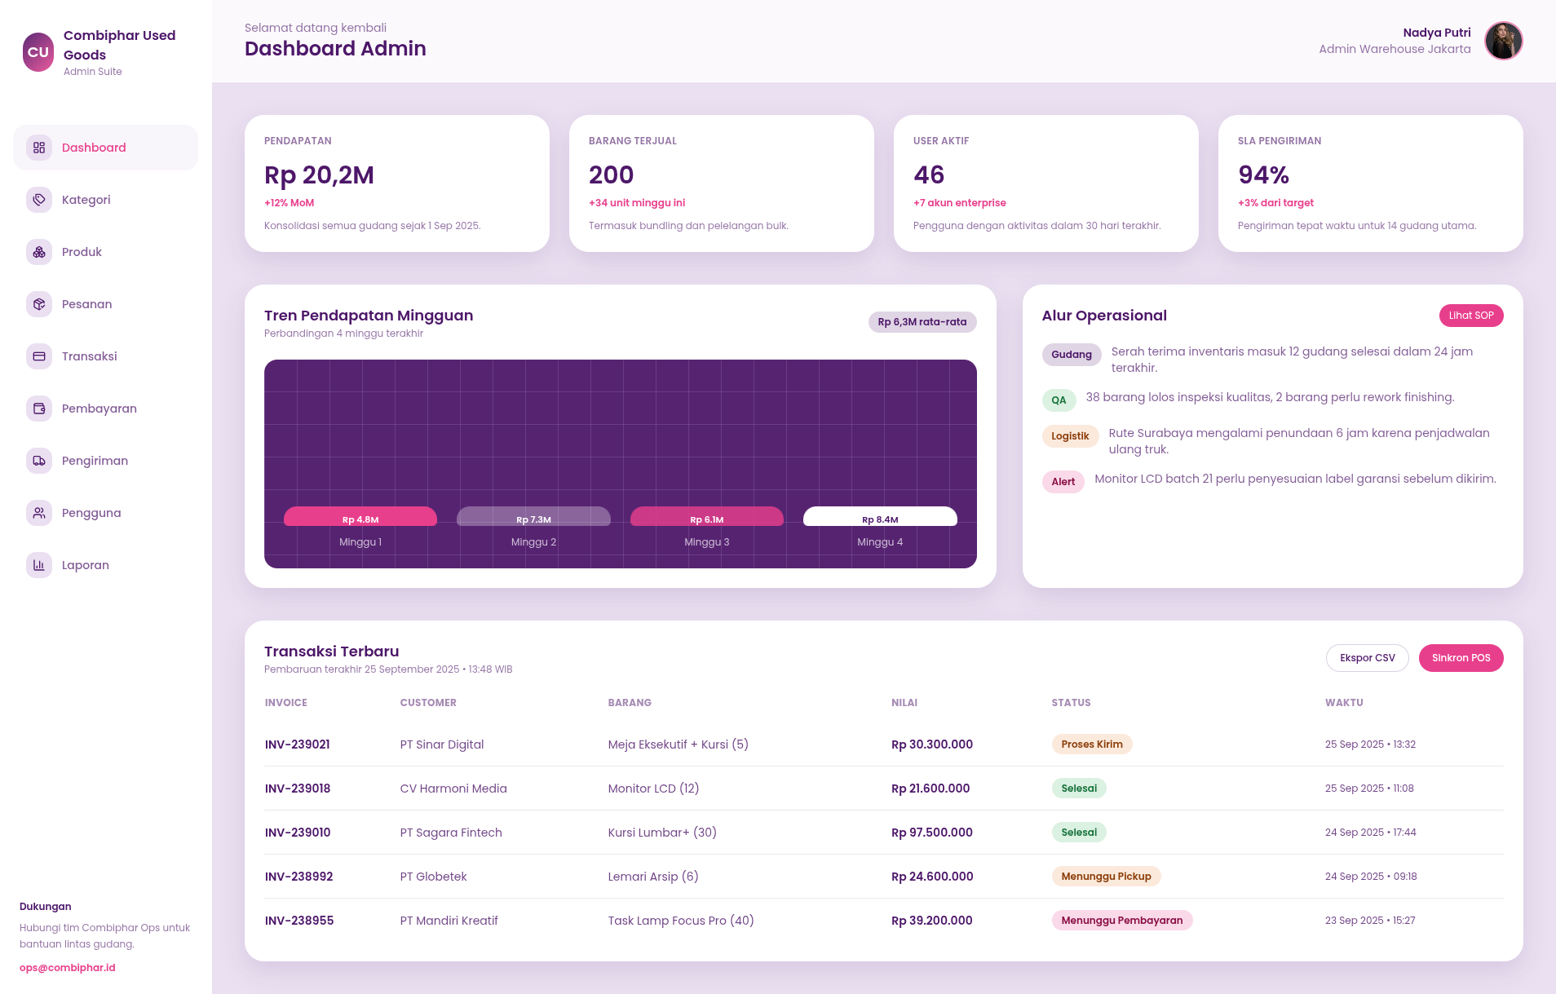

* Category Management Pages

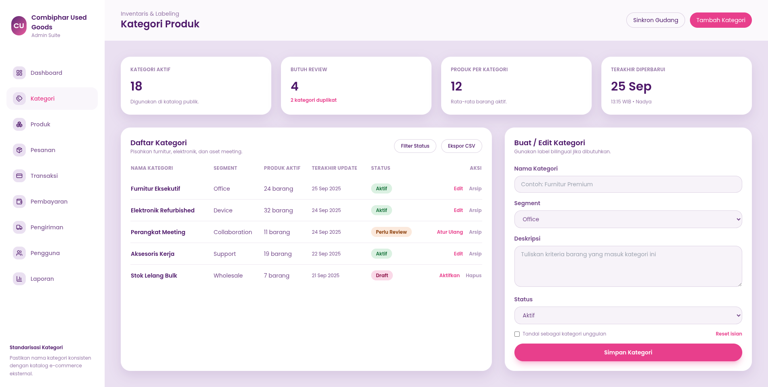

* Inventory Management Pages

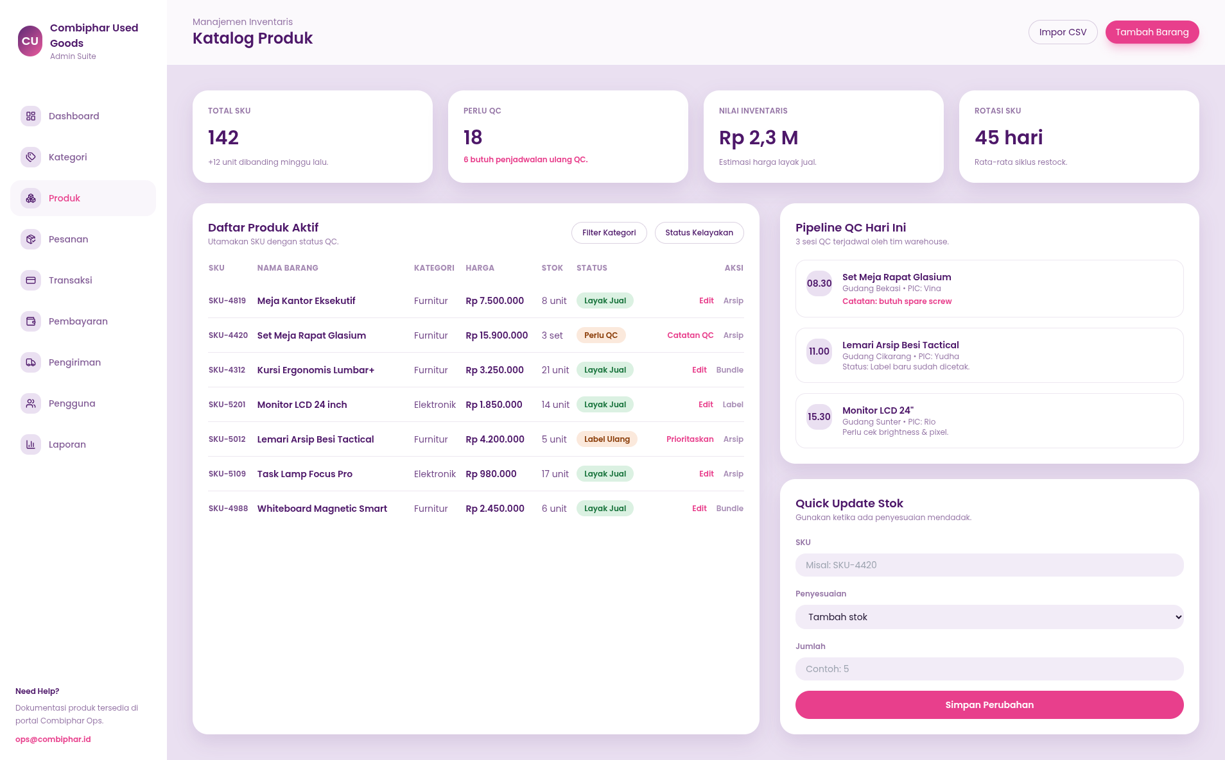

* Order Management Pages

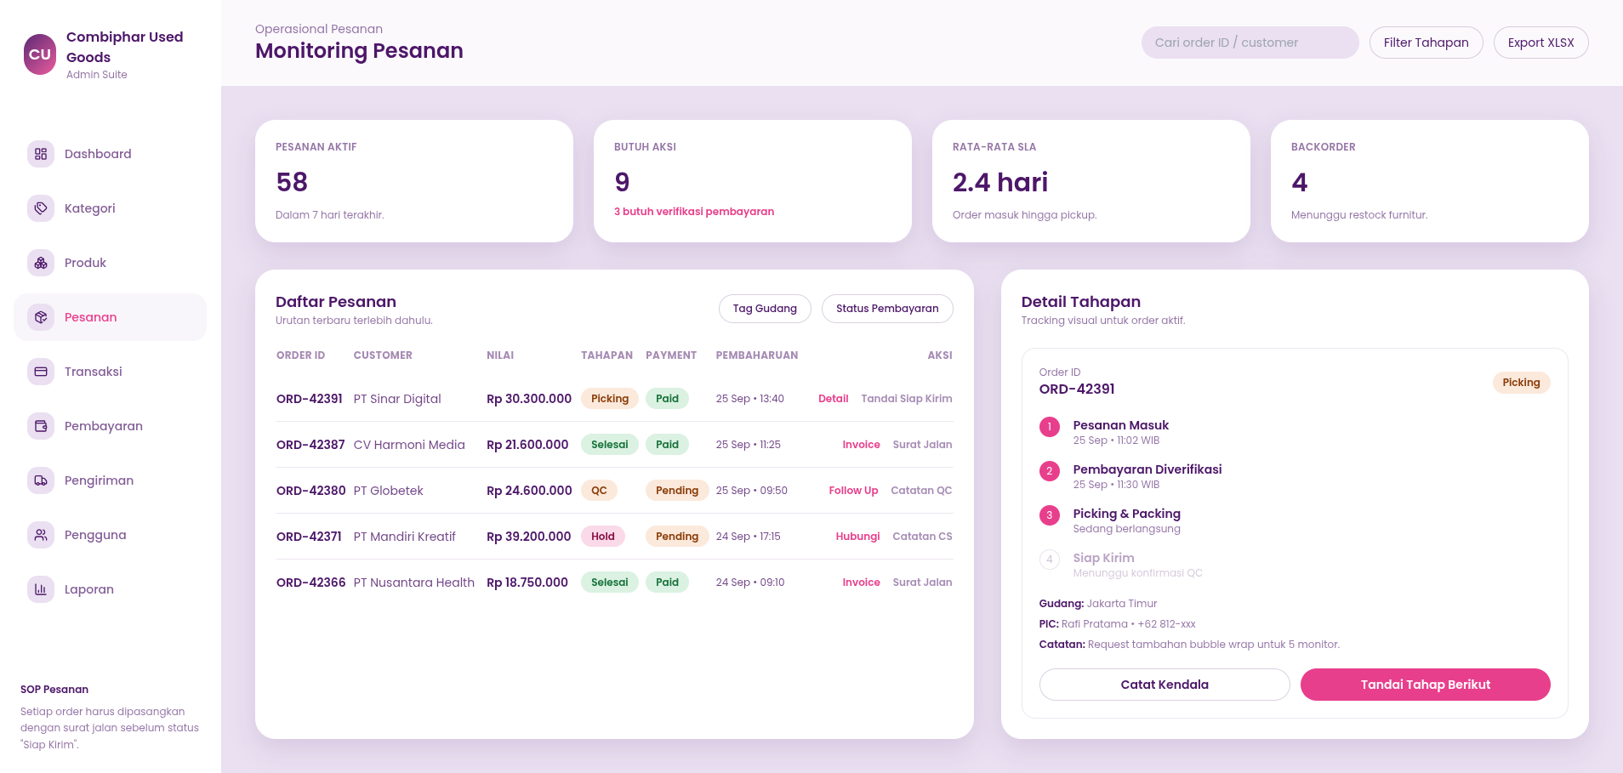

* Payment Management (Cash Confirmation)

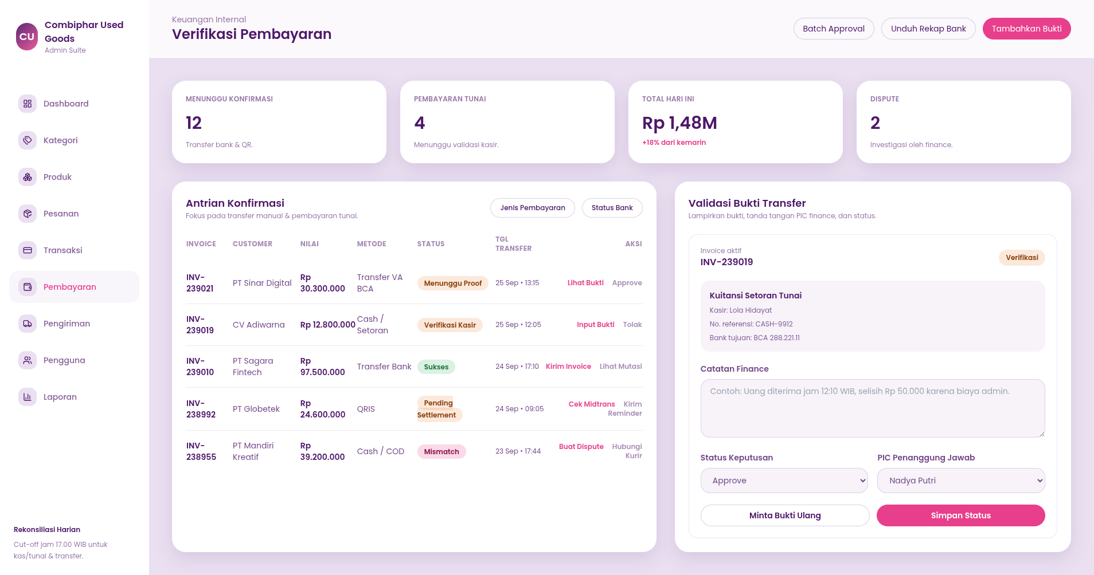

* Shipment Management Pages

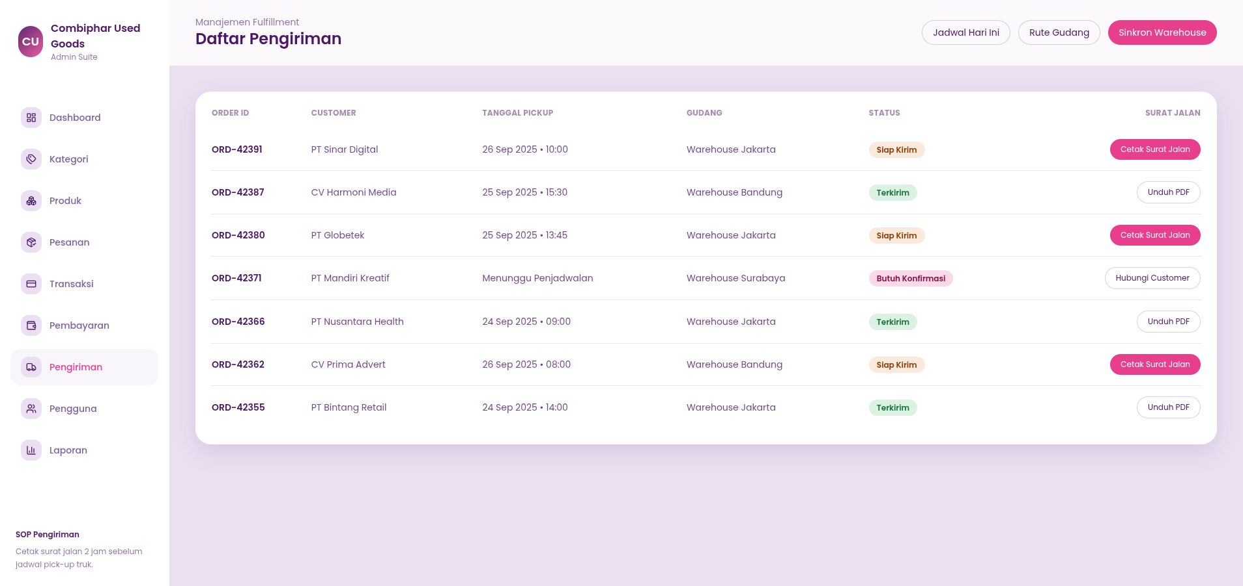

* User Management Pages

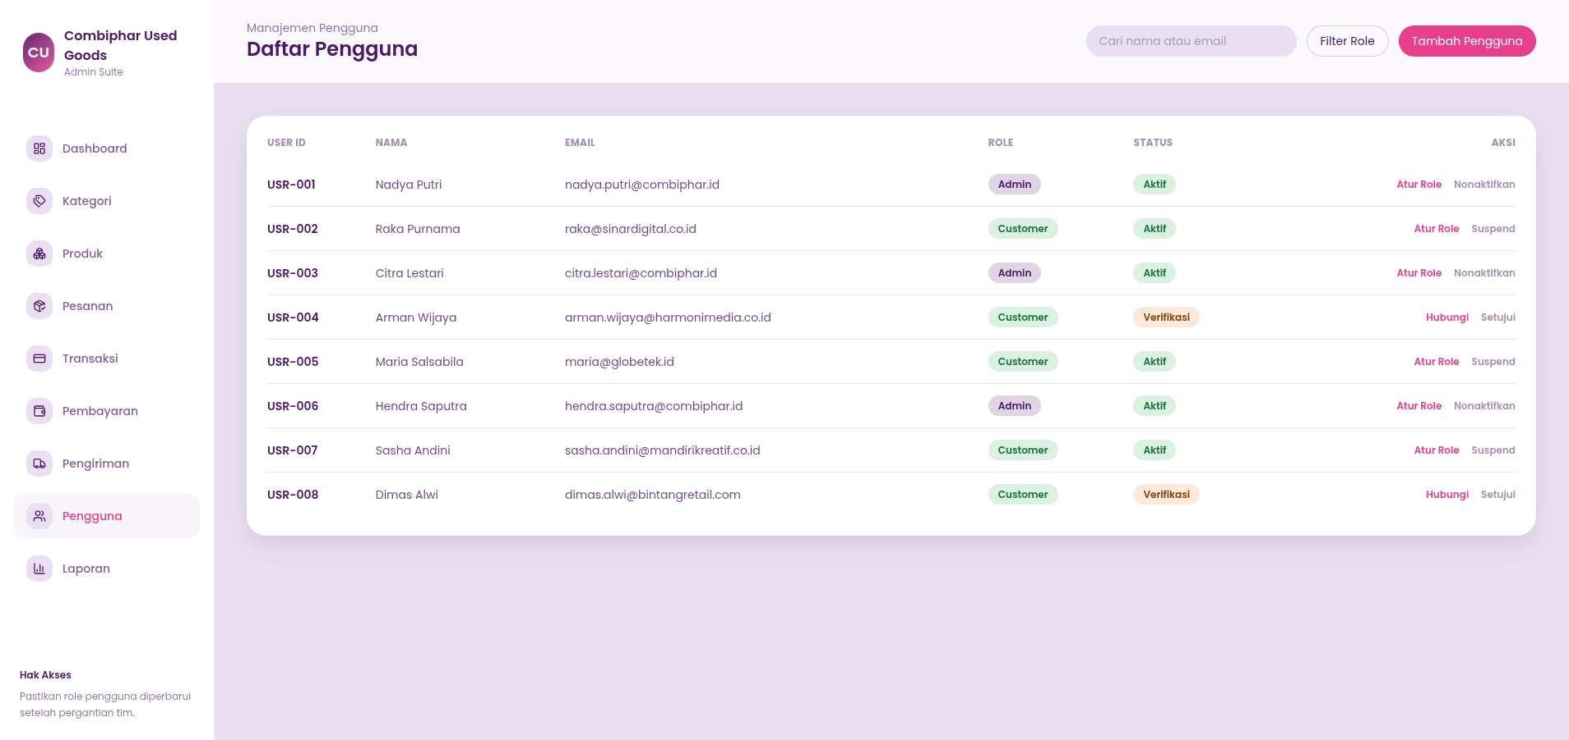

* Reporting Pages

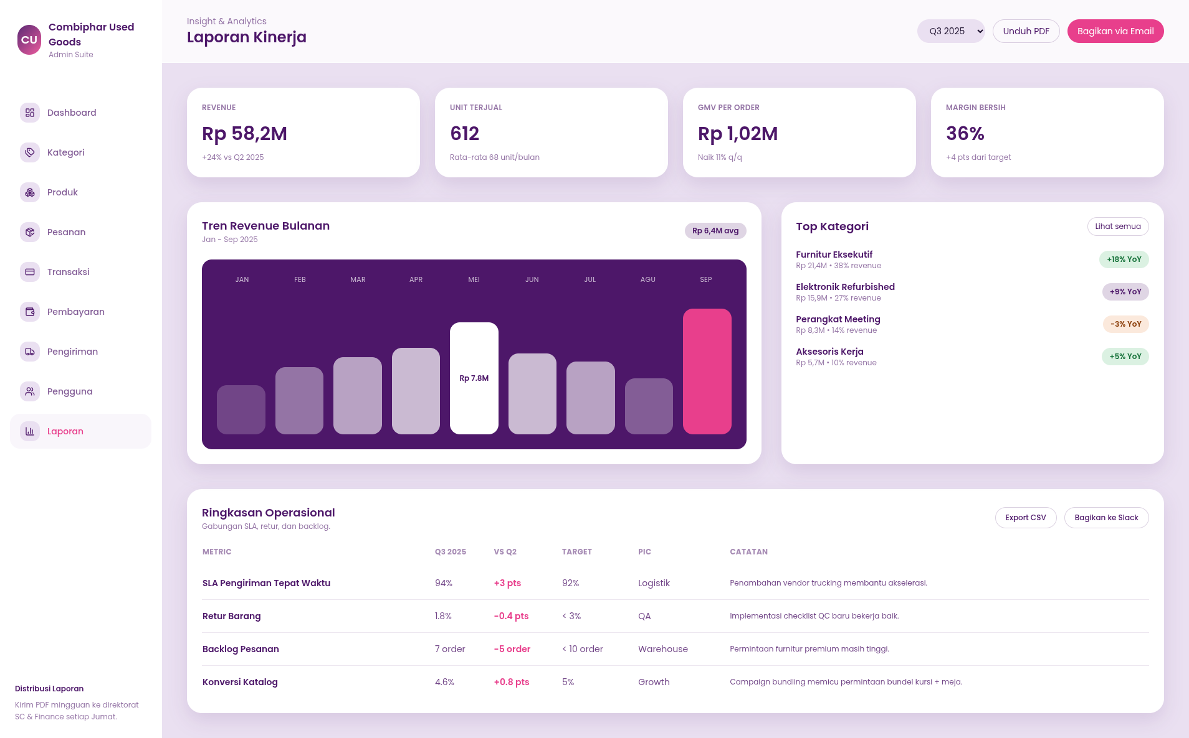

# **6. Interface Requirements**

This chapter describes the interface requirements between the system and its users, hardware, software, and external communication endpoints.

## **6.1 User Interface Requirements**

* The system shall be accessible via standard web browsers on desktop and mobile devices.
* The UI shall provide clear navigation for both customer and admin roles.
* Forms shall provide validation messages for required fields and incorrect formats.
* Pages shall be responsive so that core features remain usable on smaller screens.

## **6.2 Hardware Interface Requirements**

* The client side requires standard hardware capable of running a modern browser (PC, laptop, or mobile device).
* The server side requires a machine capable of hosting a web server, application server, and database with sufficient CPU, memory, and storage for expected load.
* Network connectivity is required between client devices and the server, and between the server and the payment gateway.

## **6.3 Software Interface Requirements**

* The web UI shall interface with the backend via HTTP/HTTPS using RESTful APIs.
* The backend shall interface with the relational database using a suitable driver/ORM (e.g., PDO, Eloquent, or similar).
* The system shall integrate with a QRIS payment provider API for generating and validating QRIS payments.
* Authentication and authorization mechanisms shall integrate with the chosen web framework’s security modules.

## **6.4 Communication Interface Requirements**

* All communication between clients and the server should use **HTTPS** to protect data in transit.
* The backend shall communicate with the QRIS payment gateway over secure channels using the provider’s API specification.
* For payment notifications (callbacks/webhooks), the server must expose endpoints accessible from the payment gateway.
* Logging should capture key communication events (e.g., payment callbacks, shipment updates) for audit and troubleshooting purposes.